How to print UC2 with Prusa I3 MK3S:

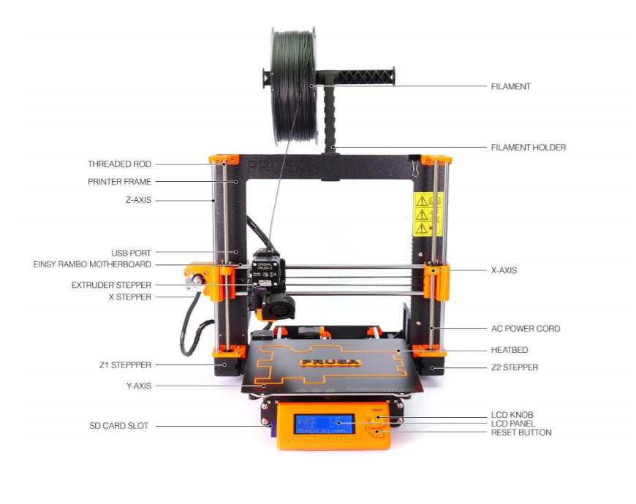

## Setup Cura for the Prusa i3

* Download Cura settings from <https://www.prusa3d.com/drivers/> and install according to instructions
* Go to: <https://manual.prusa3d.com/Guide/How+to+import+profiles+to+Cura/1421#_ga=2.216762066.53635997.1563870317-1002203748.1563870317>
* Download the archive and unpack it somewhere
* Go to Cura and import the different .curapfile files one by one -> Cura_OriginalPrusa_Profiles\Cura_3_6_0\mk3_cura_profiles\MK3_cura_profiles\04_Cura_layerheight_profiles

# Settings for UC2 prints

* For printing UC2 parts use profile MK3S_MK3_0,15_Optimal.
* Change infill to 50%.
* In general **no** support is necessary (especially for all bas-cubes and the Z-stage!)
* Material: Prusa Research Prusament PLA.
* Safe gcode to SD card.

# Printing the parts with the Prusa

* Switch on the printer (on the back, right side).
* Clean the steel sheet (build plate) with isopropylalcohol and tissue.
* Insert SD card.
* Push the control knob next to the screen (if SD card does not open automatically).
* Choose Print from SD.
* Choose your file.
* Watch the first layer or two to see if they attach properly.
* In case something goes wrong, press the reset button (X).
* Wait till your print is finished.
* Wait for it to cool down to room temperature. You can see the heatbed temperature on the screen.
* Remove the steel sheet.
* Bend the steel sheet so the parts separate from it.

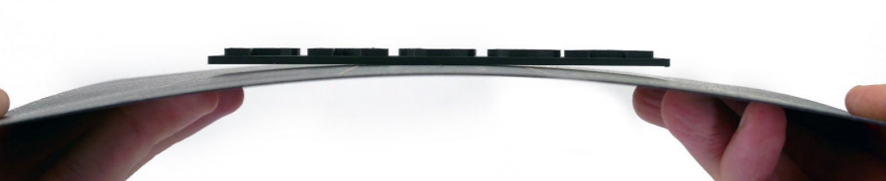

* Return the steel sheet to its correct position.

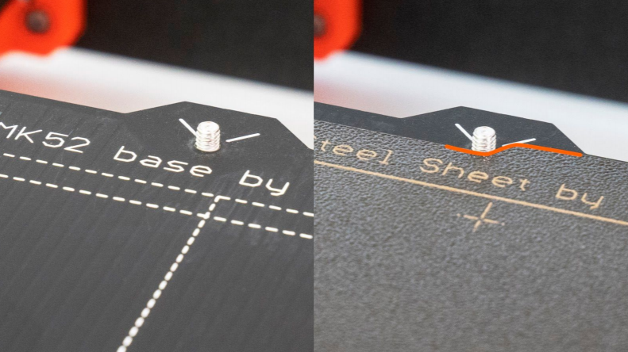

For more information – Printing Handbook <https://cdn.prusa3d.com/downloads/manual/prusa3d_manual_mk3s_en_3_11.pdf#_ga=2.211631766.2016905863.1563777341-710825333.1558506269>

**We print with PLA 1,75 mm!**